Ödev – Karaşimşek- 1.1 – Erol Akif KURTCEBE

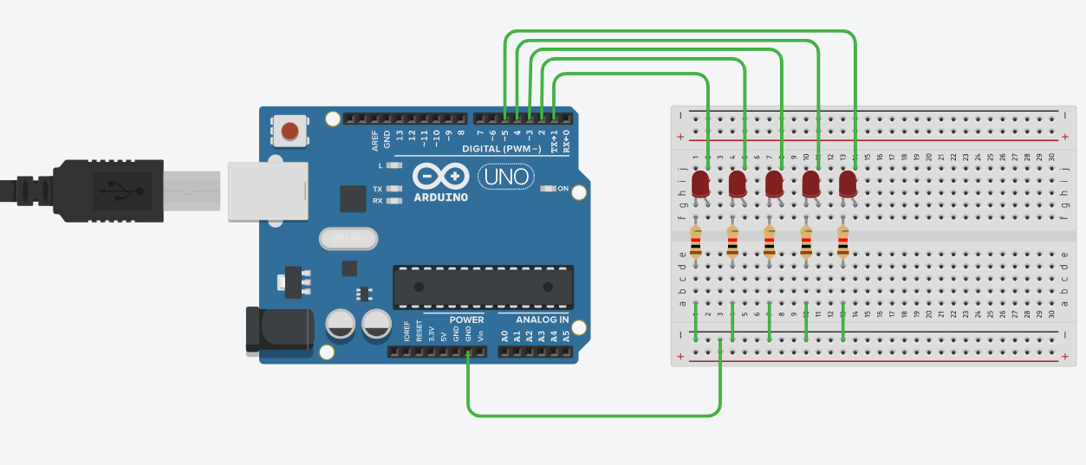

Kod:

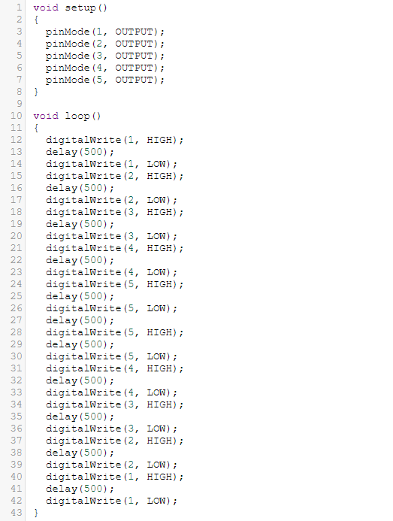

Uygulamalı video drive linki : <https://drive.google.com/drive/folders/1MEeOmWRl2-Eef5HFS_182BTcTgUI9BtJ?usp=sharing>